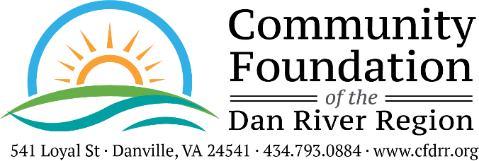

2024 INTERIM GRANT REPORT FORM
If your project has not been completed, please complete this form and return to The Community Foundation, Attn: Traci Petty, 541 Loyal Street, Danville, VA 24541 by June 21, 2024.

Reporting Organization: Organization Name Here

Project Purpose: Purpose of Project Here

Amount of Grant: Grant Amount Date of Grant: Grant Date
1. Fiscal report: Please detail what funds have been spent. Please be as specific as possible by attaching a summary of expenses with copies of cancelled checks and receipts. If funds have not been spent, please note how and when funds are to be used prior to December 16, 2024.

2. Progress Statement: Please describe the progress of your project up to this point, along with a timeline for completion. Discuss the ways your project is impacting your program and/or community. Address any challenges you are encountering with your project. Attach an additional page, if necessary.

Progress Report

This form is available for download as a Microsoft Word document at https://www.cfdrr.org/grants/applying-for-a-grant/

Person completing form: Name Of Person Title: Title Of Person Date: Date

Phone: Phone Number________________Email:Email

